Foundation & catalogue

Build a Training Management Platform called "IBM LearnHub" as a single self-contained HTML file with no external dependencies except Google Fonts.

The app has 5 navigation sections: Catalogue, My Learning, Recordings, Analytics, Admin. Show the current user as "Sanjay K · Admin" in the top right.

Start with the Catalogue view:
- A top metrics bar showing: total active courses, total enrolled learners, completion rate, avg feedback score
- A category filter row: All, Agentic AI, Cloud & Infrastructure, AMS Delivery, AI Governance, Data & Analytics, Leadership
- A search box to filter courses by title or trainer name
- A responsive card grid showing training courses. Each card shows: colour-coded category banner, course title, trainer name, date and duration, format badge (Live / Self-paced / On-demand), enrolment status badge (Open / Full / Upcoming), an enrolment progress bar showing seats filled, and an Enrol button

Pre-load 8 realistic IBM Consulting training courses across different categories. Use IBM blue (#0F62FE) as primary colour, clean flat UI, no gradients. Professional IBM consulting aesthetic.

Enrolment System : Enrolment & roster
Add the enrolment system:

When a user clicks Enrol on a course card:
- Show an enrolment modal with fields: Full name, IBM band/role (dropdown: Analyst/Consultant/Senior Consultant/Managing Consultant/Associate Partner/Partner), Location/office, Attendance mode (In-person Singapore / Virtual / In-person other)
- A Confirm Enrolment button that adds them to the roster, updates the enrolment count and progress bar in real time, and shows a confirmation screen with the course details and an "Add to calendar" button
- If the course is full, replace the Enrol button with a Join Waitlist button instead. When a spot opens, auto-notify the first person on the waitlist with a banner

In the Admin section, add an Attendee Roster view:
- A dropdown to select which course to view
- A table showing: name, band, location, attendance mode, enrolment date, completion status (enrolled / attended / completed / no-show)
- A button to export the roster as a downloadable CSV file
- Admin can mark individual attendees as attended or completed after the training

Pre-populate 6 realistic attendees across 2 courses so the roster looks live.

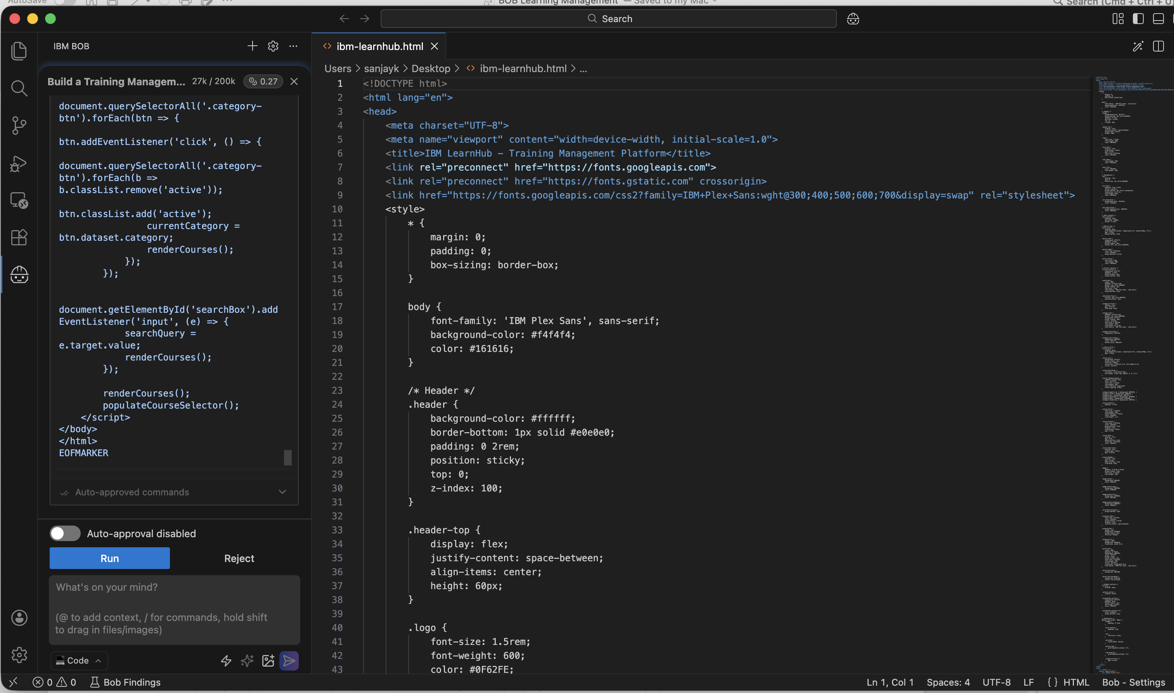

Prompt 3 — Recording upload & on-demand
Add the post-training content management system:

In the Admin section, add a "Upload Training Content" panel for each completed course:
- Recording URL field (accepts YouTube, MS Teams, or Vimeo links)
- Slide deck upload (simulated — store the filename and show an upload confirmation)
- Additional materials: up to 3 reference document links with labels
- A "Publish content" button that makes the course available as On-demand

In the Recordings section (visible to all users):
- Show all courses that have recordings available as a grid of cards
- Each card shows: colour-coded category thumbnail, title, trainer, original date, duration, embedded video player placeholder, and links to materials
- A search and category filter bar at the top
- A "Mark as watched" button for self-paced progress tracking
- Show a "New" badge on recordings published in the last 7 days

When a course is published as on-demand, automatically update its status badge in the Catalogue to "On-demand" and show recording and material links on the course card.

Prompt 4 — Feedback, ratings & certificates
Add the feedback and certification system:

Feedback form (shown to attendees after training is marked complete):
- 5-star overall rating with hover interaction
- 3 structured rating questions (each 1-5 stars): Content quality, Delivery & presentation, Practical applicability
- Open comment fields: "What did you find most valuable?" and "What could be improved?"
- Would you recommend this training? Yes / No / Maybe
- Anonymous submission toggle
- Thank you confirmation screen after submitting

On each course card and course detail page show:
- Average star rating with total response count
- Visual breakdown of the 3 structured questions as small bar charts
- The 5 most recent non-anonymous comments in a scrollable feed
- Trainer can see all feedback including anonymous in Admin panel

Completion certificates:
- When admin marks attendee as "Completed", auto-generate a printable certificate
- Shows: learner name, course title, date completed, trainer name, duration/CPD hours, IBM Consulting branding, unique certificate ID
- "Download certificate" button on My Learning page
- Certificates shareable via unique URL

Pre-populate realistic feedback for 2 existing courses (8-10 responses each).

Prompt 5: Analytics, My Learning & final polish

Add the final two sections and polish everything:

Analytics dashboard (Admin only):
- Key metrics: total learners trained this year, total training hours delivered, avg feedback score, courses published
- Bar chart showing trainings delivered per month (last 6 months) using CSS bars
- Category breakdown by enrolment popularity
- Top 3 trainers leaderboard by enrolments and avg feedback score
- Completion funnel: enrolled vs attended vs completed vs feedback submitted

My Learning page (personal view):
- Upcoming enrolled courses with countdown in days
- Completed courses with my rating and certificate download button
- Unwatched on-demand recordings recommended by category history
- My learning streak: consecutive weeks with at least one activity
- Summary card: total hours learned this year, certificates earned, feedback given

Final polish:
- "Launch new training" floating button for admins — opens a full form with title, description, category, trainer, date, time, duration, format, max seats, pre-requisites, and agenda field
- Smooth fade transitions between navigation sections
- Friendly empty state messages (not blank screens)
- Footer: "IBM LearnHub · Application Operations Practice · Built with IBM Bob"
- All state in memory — app works fully offline, no server calls

